New Primary Care Office Opening in Winter Springs
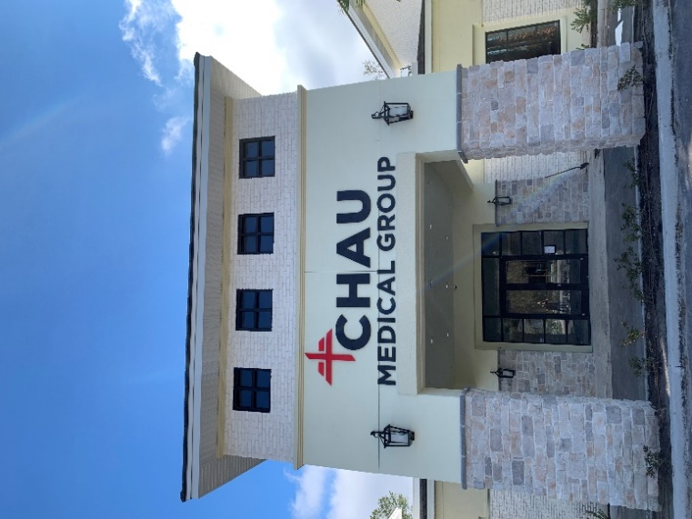
Chau Medical Group is excited to serve the Winter Springs community at their second location!
Chau Medical Group is a family-owned primary care office that has been serving the Central Florida community since 1991.
Dr. Son Chau opened his practice in 1991 after completing his residency in internal medicine at Orlando Health. His daughter, Dr. Annie Chau, and her husband, Dr. Huy Le, joined in 2018 after completing their residencies at the same hospital!
All physicians are board-certified in internal medicine, geriatric medicine, and obesity medicine.
Chau Medical Group practices traditional medicine. They follow their patients in the office, hospital, and nursing home setting to ensure a seamless continuation of care.
Chau Medical Group offers annual physical exams, preventative exams, medication reviews and in-office lab draws. In addition, they manage many common medical conditions including diabetes, high blood pressure, and high cholesterol.
Chau Medical Group takes pride in providing the best primary care for their patients. They also have a special interest in weight loss and teaching their patients daily habits to optimize their health and promote wellness.
Chau Medical Group is accepting new patients! Many insurances are accepted, including Medicare, Humana, Tricare and commercial plans. Please call our office for a list of accepted insurances.

411 E. State Road 434 | Winter Springs, FL 32708
Phone 407-273-9410 | www.sonchaumd.com
Please call for the most updated hours.

