**Waste Pro Solid Waste Services**

* Household garbage and recycling services resumed normal pick up schedule on Monday, 10/3/22.
* Bulk day will continue to be picked up on the 2nd pick up day of your regular scheduled service.
  + 3 bulk items may be placed at the right of way.

Please be patient as our crews are picking up increased volume of waste.

**Yard Waste Pick Up**

Please see the diagrams for Waste Pro yard pick up schedules.

* First phase will start with the area map in **BLUE** which represents the Tue/Fri routes. This section will be serviced on Wed 10/5 & Sat 10/8
* Second phase will start with the area map in **GREEN** which represents the Mon/Th routes. This section will be serviced on Wed 10/12 & Sat 10/15
* If yard waste is not picked up on the first two pick up dates, trucks will be back on the next scheduled pick up.

Yard waste guidelines:

* All debris should be placed on the right of way by 6am on your pick up date.
* Debris placed on the street or property will not be picked up.
* Small debris such as leaves should be placed in bags, bundles or containers not to exceed 50 pounds for containers or 25 pounds for bags.
* Leave materials that have not been picked up for next pick up. Do not re-container materials.

**Debris Waste Haulers**

* The City of Winter Springs has contracted debris pick up crews.
* Crews will rotate throughout the city in multiple passes. (see map on our website updates <https://www.winterspringsfl.org/community/page/debris-pickup>)
* If crews have not picked up at your address, rest assured they will return soon as they are picking up in passes.
* All debris must be placed on the right of way.
* Debris placed in the street, sidewalks or on property will not be picked up.
* Crews are not equipped to rake or gather small debris.
* Do not lean debris on poles or trees.
* Debris trucks will not pick up bagged items, house hold waste or recycling.

**Waste Pro - Phase One Pick Up**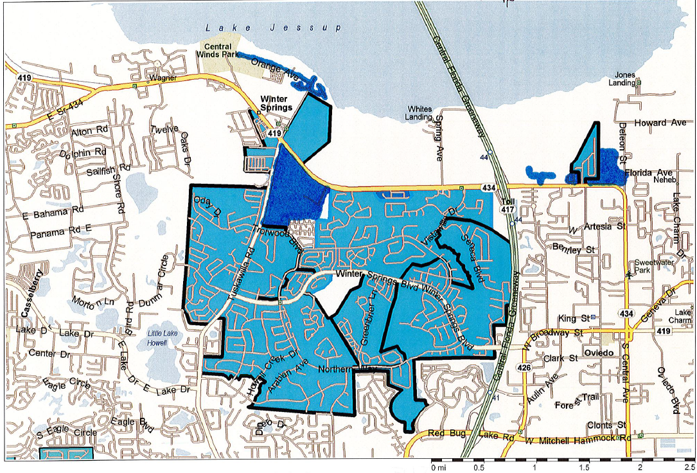

**Waste Pro - Phase Two Pick Up**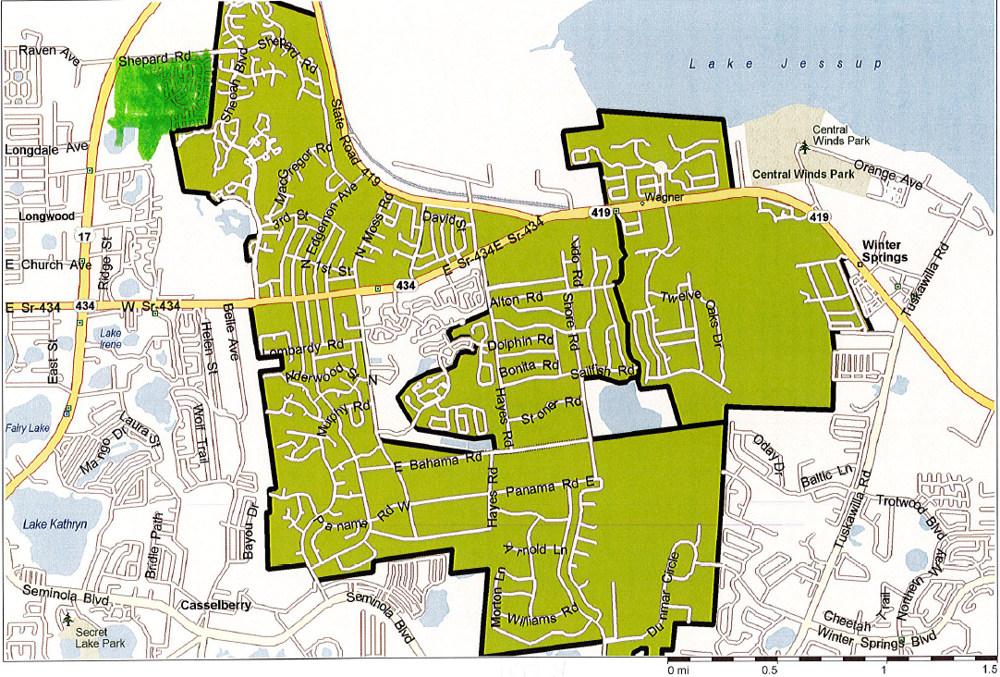

**Debris Separation Tips**

