For Immediate Release:

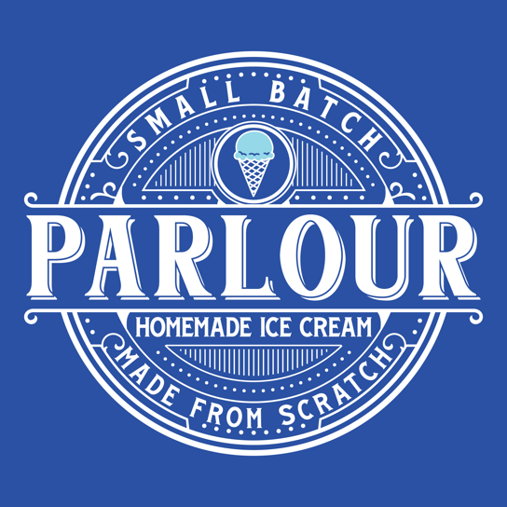

Parlour Ice Cream to host grand-opening event
Winter Springs, Florida — Parlour Ice Cream, a new, locally owned and operated, artisanal, homemade ice cream shop, located in Winter Springs Town Center, will hold its grand opening- ribbon cutting ceremony at 1:00 p.m. Saturday July 16.
Join us Saturday and enter to win free ice cream for a year! Drawing will be held at closing Saturday night for entries collected during operating hours of grand opening. Must attend grand opening day and enter onsite at Parlour Ice cream.
The shop, which opened just over 2 months ago, will hold a ribbon cutting at the event. Parlour Ice Cream is owned and operated by Oviedo /Winter Springs Native Jason Bethune and his wife Dawn.
Parlour Ice Cream serves a variety of unique hand-crafted ice cream flavors, all produced with local ingredients, onsite. The shop stocks 24+ ice cream and vegan ice cream flavors along with waffle cones, brownie and cookie sundaes, milkshakes, floats, pints, and quarts to-go.

We are open Sunday – Thursday 1:00pm – 9:00pm
Friday and Saturday 1: oopm-10:00pm

Parlour Ice Cream
158 Tuskawilla Road Ste. 1304
Winter Springs, FL. 32708
Theparlouricecream@gmail.com
407-542-3049
www.Theparlouricecream.com
Contact: Jason Bethune

