How to Plant a Maple Tree

Soil

Most maple trees are adaptable to many soil types, including clay. They prefer a well-drained but moist soil of average fertility. Though some maple varieties will grow in swamps, other will handle periods of wet soil due to heavy rainfall but constantly wet soil could be problematic.

Soil pH

Maple trees grow best in an acid to neutral soil ranging from 5.0 to 7.0 on the pH scale. Most average garden soils fall between a pH range of 6.0 to 7.0.

Light Needs

Maple trees grow best in full sun however will tolerate a fair amount of shade. Branching and foliage will be denser with more sun.

Tree Size When Mature

The red maple grows to a height of 40–60' and a spread of around 40' at maturity.

Planting a Maple Tree in the Ground

Step 1

Start by digging your planting hole at least three times as wide and as deep or not much deeper than the root ball of your maple tree. The wider the hole the better. Place native soil removed from planting hole around the perimeter of the hole, in a wheel barrow, or on a tarp.

Step 2

Depending on the type, fertility and porosity of the soil in the planting area, it may be beneficial to amend the native soil. When planting in dense clay or other compacted soils it is beneficial to thoroughly mix in some bagged top soil or a good planting mix at a 25 to 50% ratio with the native soil removed from the planting hole. When planting in very sandy, quick-draining soil consider mixing in some top soil, peat moss and/or compost to help retain moisture. When planting in well-drained but moist soil of average fertility there is no need for adding a soil amendment.

Step 3

To remove your maple tree from the nursery container it was growing in, firmly grasp the base of its trunk and try to gently lift and remove it from its container. If the root ball is stuck in the container either cut the container away or place the tree on its side and tap on the side of the container to loosen the root ball. After having removed your tree from the container, use your fingers or a claw tool to loosen some feeder roots around the surface of the root ball. If root bound, you can spray the sides and bottom of the root ball with a stream of water from a garden hose. This will help to wash away some soil from the exterior of the root ball making it easier to loosen roots.

Step 4

If you are planting in well-drained soil set your maple tree in the planting hole so that the top edge of the rootball is at or slightly above ground level. If necessary, add some backfill soil mixture to the bottom of the hole to achieve proper planting height.

Note: If the soil is poorly drained (constantly soggy or wet), and you are planting a maple variety that prefers well-drained soil, either improve drainage, plant the root ball in a raised mound entirely above ground level, or select a different tree species more tolerant of wet soils, such as river birch.

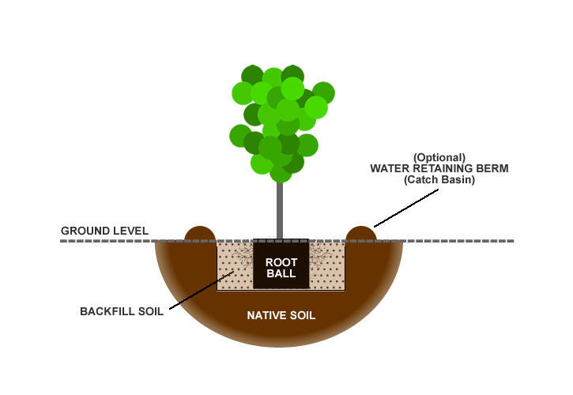

Step 5

After setting your maple tree in the planting hole, use one hand to hold the tree straight and your other hand to begin back-filling your soil mixture around the root ball, tamping as you go to remove air pockets. When you have filled the hole to the halfway point you can soak the soil. Then continue back-filling to the top edge of the root ball. If you are planting higher than ground level taper your soil mixture gradually from the top edge of the root ball to the ground level. To avoid suffocating your tree, avoid placing any soil on top of the root ball. You can place mulch on top of the root ball later.

Step 6 (Optional)

When planting a maple tree in a location that is far from a water source, and that has well-drained soil, you can use remaining soil mixture to build a water retaining berm (catch basin) around the outside perimeter of the planting hole. This basin will help to collect water from rainfall and irrigation often reducing the need for hand-watering. The berm can be removed after a year or so when your tree has established itself.

Step 7

Next, deeply water the planting area, including the root ball, to a depth equal to the height of the root ball.

Step 8

To conserve moisture and to suppress weed growth, apply a 2" layer of cured, shredded or chipped wood mulch or pine straw around the planting area. As the mulch decomposes it will add vital nutrients to the soil that your tree will appreciate. Avoid the use of freshly chipped or shredded wood for mulch until it has cured in a pile for at least 6 months, a year is better. Avoid placing or piling mulch directly against the base of your tree as doing so could cause the bark to rot.

