How to Plant a Tea Olive
Soil
Tea Olive aren't too picky about soil type, but they do prefer a well-drained soil of average fertility. As with so many other types of ornamental plants, constantly soggy or wet soil can cause root rot and other harmful plant diseases. So make sure to plant your tea olive in a well-drained site!
Soil pH
Tea Olive grow best in an acid to slightly alkaline soil ranging between 5.5 to 7.5 on the pH scale. Most average garden soils fall between a pH range of 6.0 to 7.0.

Light Needs

Tea Olive can be grown in full sun or part shade. A minimum of 4 to 5 hours of direct sunlight is recommended for best foliage density and heaviest flowering.

Tea Olive Tree Size when Mature

The Tea Olive is a slow growing shrub with a mature height of 10’ and a mature width of 6-8’.

Planting Tea Olive in the Ground

Step 1

Start by digging your planting hole at least three times as wide and as deep as or not much deeper than the root ball of your Tea Olive. The wider the hole the better. Place native soil removed from planting hole around the perimeter of the hole, in a wheel barrow, or on a tarp.

Step 2

Depending on the type, fertility and porosity of the soil in the planting area, it may be beneficial to amend the native soil. When planting your Tea Olive in dense clay or other compacted soils it is beneficial to thoroughly mix in some bagged top soil or a good planting mix at a 50/50 ratio with the native soil removed from the planting hole. When planting in very sandy, quick-draining soil you might want to consider mixing in some top soil, peat moss and/or compost to help retain moisture. When planting in well-drained but moist soil of average fertility there is no need for adding a soil amendment.

Step 3

To remove your Tea Olive from the nursery container it was growing in, firmly grasp the tree or shrub by the base of its trunk and try to gently lift and remove it from its container. If the root ball is stuck in the container either cut the container away or place the plant on it's side and tap on the side of the container to loosen the root ball. After having removed the plant from the container, use your fingers or a claw tool to loosen some feeder roots around the surface of the root ball. If root bound, you can spray the sides and bottom of the root ball with a stream of water from a garden hose. This will help to wash away some soil from the exterior of the root ball making it easier to loosen root
Step 4

If you are planting in well-drained soil set your Tea Olive in the planting hole so that the top edge of the root ball is at or slightly above ground level. If your soil drains slowly, holding water for an extended period of time after rainfall or irrigation, the top of the root ball should be 2 to 3 inches above ground level. If necessary, add some backfill soil mixture to the bottom of the hole to achieve proper planting height.

Note: If the soil is poorly drained (constantly soggy or wet) either improve drainage or plant the root ball in a raised mound entirely above ground level or select a different plant species more tolerant of wet soils.

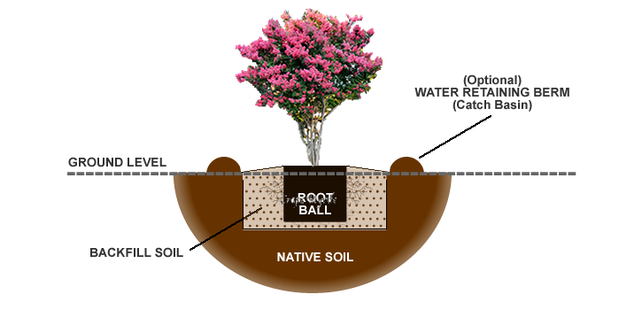

Step 5

After setting your Tea Olive in the planting hole, use one hand to hold the tree straight and your other hand to begin back-filling your soil mixture around the root ball, tamping as you go to remove air pockets. When you have filled the hole to the halfway point you can soak the soil. Then continue back-filling to the top edge of the root ball. If you are planting higher than ground level taper your soil mixture gradually from the top edge of the root ball to the ground level, as shown in the planting diagram above. To avoid suffocating your plant, avoid placing any soil on top of the root ball. You can place mulch on top of the root ball later.

Step 6 (Optional)

When planting Tea Olive in a location that is far from a water source, and that has well-drained soil, you can use remaining soil mixture to build a water retaining berm (catch basin) around the outside perimeter of the planting hole. This basin will help to collect water from rainfall and irrigation often reducing the need for hand-watering. The berm can be removed after a year or so when your tree has established itself.

Step 7

Next, deeply water the planting area, including the root ball, to a depth equal to the height of the root ball.

Step 8

To conserve moisture and to suppress weed growth, apply a 1 to 2" layer of cured, shredded or chipped wood mulch or Tea Olive straw around the planting area. As the mulch decomposes it will add vital nutrients to the soil that your plant will appreciate. Avoid the use of freshly chipped or shredded wood for mulch until it has cured in a pile for at least 6 months, a year is better. Avoid placing or piling mulch directly against the base of your Tea Olive as doing so could cause the bark to rot.

