Week of 04/07/22:

Water Plant No. 1 Capacity and Chemical Improvements – Status – Complete
The work has been completed at the water plant increasing capacity and improving chemical treatment. This was a critical first step in improving the water taste and odor. By completing this upgrade we have increased throughput capacity by 30% and optimized our chlorine injecting system realizing a 50% reduction in chlorine consumption. The project was designed and overseen by Carollo Engineers and work completed by Sawcross Construction. The picture shows the new header that was installed and connected to the water plant pumps.

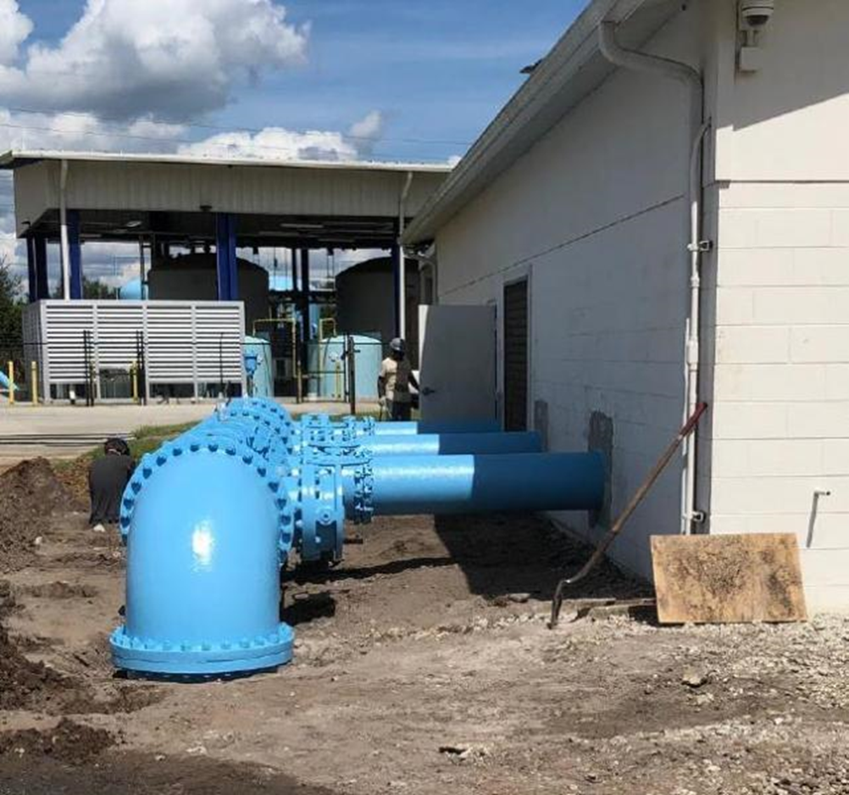

Water Plant No. 1 Well Improvements – Status - Underway
Carollo Engineers has completed a comprehensive evaluation of the condition of the wells with CCTV inspection and water testing. They have designed a project to increase capacity to wells in order to improve flow through the plant. The project will allow the City to maximize withdrawal of the highest quality groundwater, optimize treatment efficiency and increase overall wellfield reliability. The project is scheduled to be completed in May 2022.
The project will include fitting two of the four groundwater wells supplying Water Plant No. 1 with larger capacity pumps, high thrust motors, and new electrical switchgear. Additionally, pump discharge head and stuffing box assemblies will be refurbished.
Water Plant No. 2 Reliability - Underway
This project is scheduled to be completed in July 2022. The contractor, ESI has placed the new standby generator is completing installation of a new Variable Frequency Drive (VFD) controller, generator Automatic Transfer Switch (ATS), associated conduit, and wiring. Once completed, Water Plant 2 will be fully capable of operating independent of the commercial power grid at full capacity during electrical outages. The picture below shows the standby generator placed in its final location on the newly constructed generator pad.
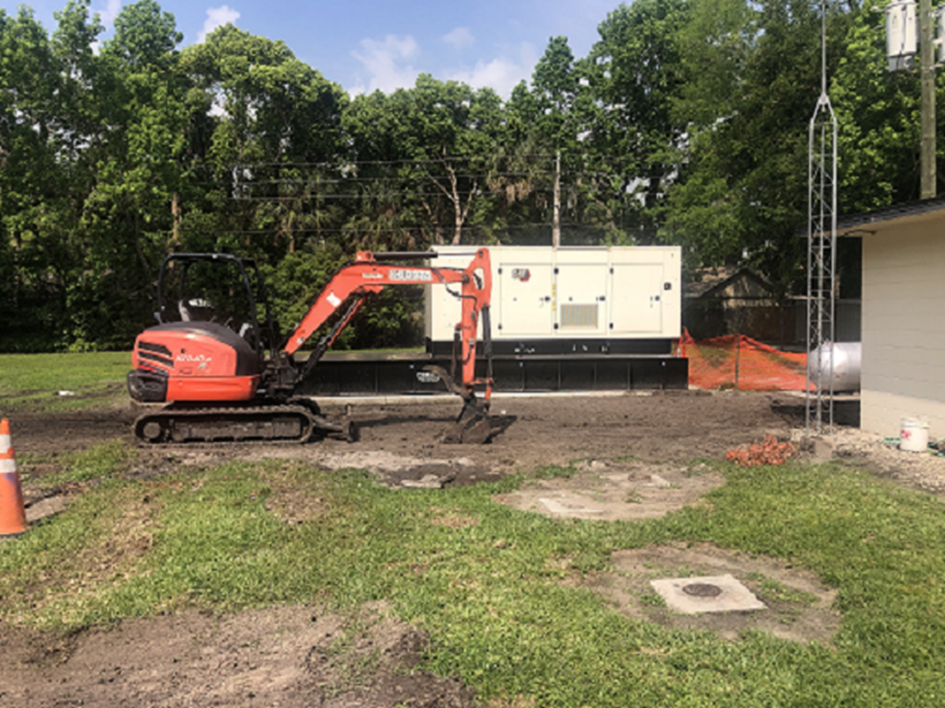

Priority Repairs - Underway

The City’s Wastewater Treatment Facilities are more than 50 years old, and are tedious and labor intensive to operate requiring constant monitoring and manual adjustments operational adjustments to meet treatment standards. Because of the structural and mechanical issues, there is an inherent risk associated with any maintenance, repair and construction activities. Progress has been steady. With much of the structural work completed at the East Wastewater Treatment Plant, focus will soon shift to refurbishing the clarifier assembly, upgrading primary air supply piping, and basin aerators. The photo below shows refurbished influent troughs, and curtain wall reinforcement.

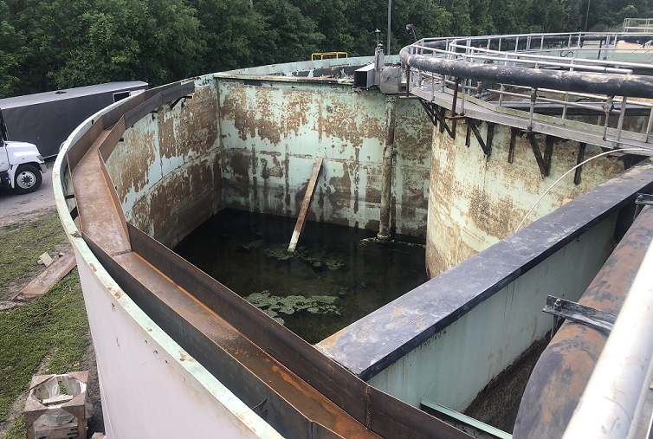
The photo below shows a large steel panel shortly after being welded in place to replace a failing panel prior to completing surface preparation and coating. 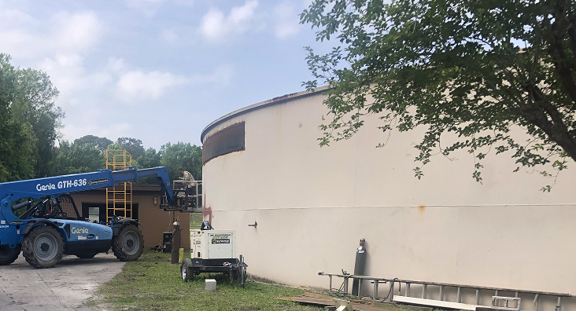
Steady progress is also being made at the West Wastewater Treatment Plant. Having to contend with infrastructure in excess of 50 years old, along with structural, and mechanical issues while maintaining plant operations can be complicated and risky. Earlier this week while completing concrete core drilling operations on the Traveling Filter Bridge Complex, a temporary cofferdam structure designed and installed to hold back fully clarified water failed. While dislodging the concrete core from the structure, force exerted on the 300 lbs. concrete core during the removal process transferred to the cofferdam causing the cofferdam to fail. As a result, fully clarified water escaped from the structure. Within eight minutes of the cofferdam failure, operations personnel had re-routed flow, contained all effluent to the plant, and began recovering the clarified water. With plant operations restored, and core drilling complete, work continued and 20 inch diameter piping was installed, connecting a highly efficient disc filter to the plants piping network. The disc filter will provide efficient and effective filtration, and bolster plant reliability throughout the construction process. The photo below shows the disc filter unit.
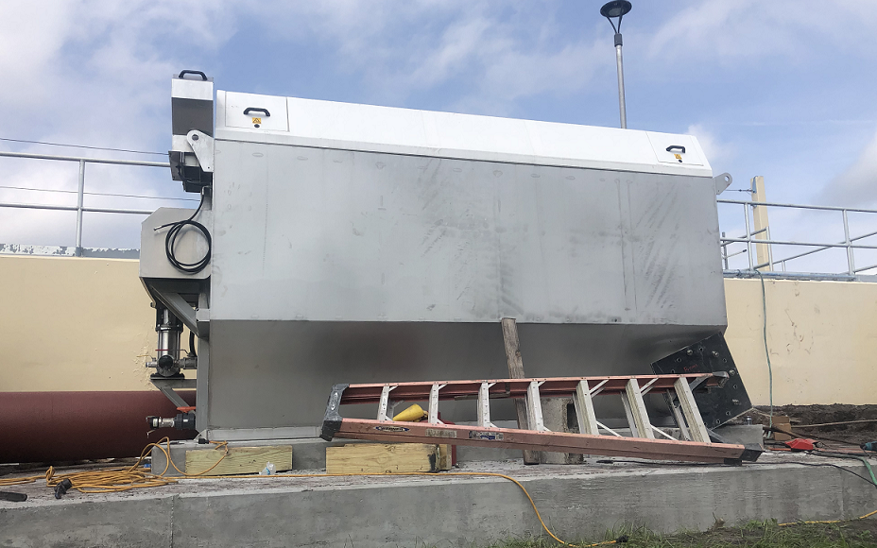
The photo below shows the disc filter unit, associated piping, and isolation valves being installed.
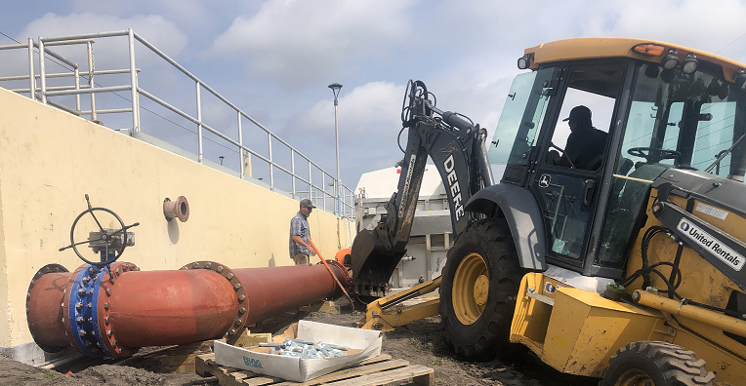

Building New Wastewater Plants
The City finished preliminary engineering of new wastewater plants using two different engineering firms – Kimley-Horn and Carollo. Both are nationwide engineering firms with extensive experience in wastewater treatment.
- Wastewater Master Plan - Kimley-Horn has completed a comprehensive plan after evaluating the entire wastewater system, to include all, collection, transmission, conveyance, and treatment infrastructure. This plan helps the City forecast wastewater needs for the next 20 years. This document is a critical step to the City obtaining State financing for the project. The plan will be discussed during the public hearing in April 2022.
- Conceptual Design Reports - Carollo Engineers has evaluated the wastewater plant sites and provided the City with the different options for treating the waste. This includes focusing on the desired water quality, reliability, reducing odors and noise from the plants. Their work, now complete will be part of the Wastewater Master Plan. Updates on the process of this study were made at the December 2021, February 2022, and March 2022 Commission meetings. Final recommendations were presented to the Commission in March 2022, and both the East and West Wastewater Treatment Plant Conceptual Design Reports will be discussed during the public hearing in April 2022.

Expanding Reuse System
The City was awarded a St Johns River Water Management District grant providing funds to help expand the reuse system along State Road 434. Kimley-Horn has finalized the design. The City has solicited request for proposals, and expects to move to award in May 2022. This project will shift in excess of 300 homes, and certain park areas from potable irrigation water to reuse irrigation water, reducing the demand on our ground water source by more than 50 million gallons per year.

